

MASTER OF COMPUTER and INFORMATION SCIENCES

408216
Data Mining & Knowledge Engineering

SAS Tutorial

Introduction
SAS stands for Statistical Analysis Software. It is an integrated applications system that allows users to perform:
- Analysis of variance
- Bayesian analysis
- Categorical data analysis
- Cluster analysis
- Regression
- Nonparametric analysis
- Psychometric analysis
- Statistical analysis
- Survival analysis
- Survey data analysis
- …
SAS is one of the most widely used statistical software in many fields, including aerospace, automotive, banking, communication, education, healthcare, govt. insurance, life sciences, etc.

The purpose of this tutorial is to assist beginning users to quickly get started with SAS software.

Using Built-in Help
SAS software has build-in help features that provide comprehensive coverage of how to use the software and syntaxes (command codes).
* HELP SAS Help and Documentation

SAS Windowing Environment
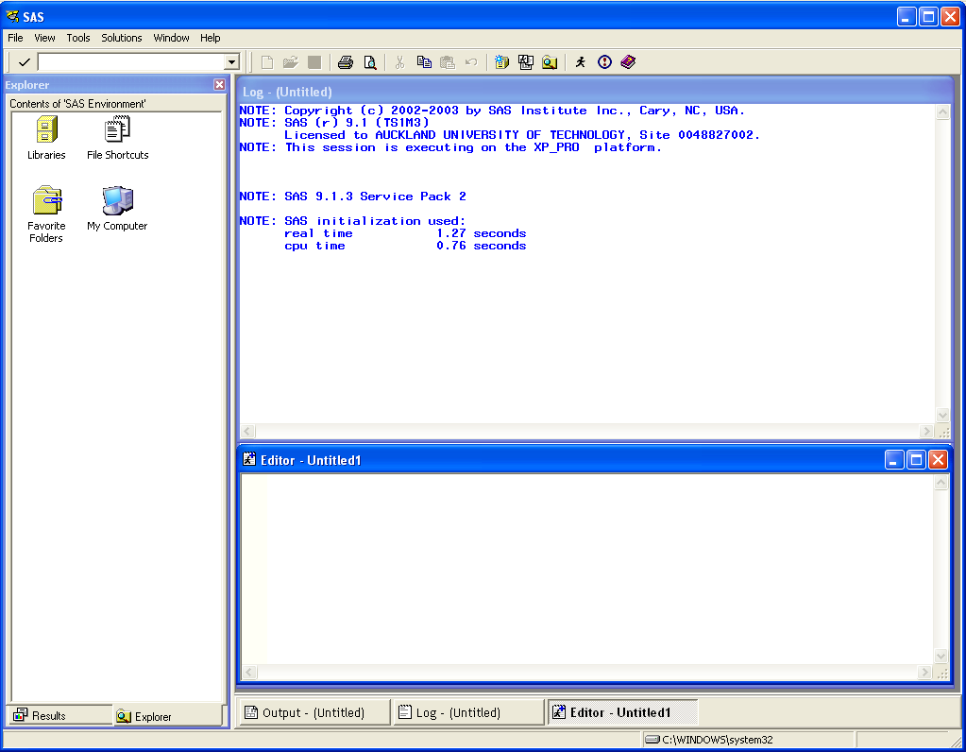
- Results window
- To navigate and manage output from the SAS program you submit.
- To view, save, and print individual items of output.

- Explorer window
- To view and manage SAS files and create shortcuts to non-SAS files.
- To create new libraries and SAS files, open any SAS files and perform most file management tasks such as moving, copying and deleting files.

- Log window
- To see the errors if any in your code after execution.

- Editor window
- To input your command codes.
Reminder! Do not forget to put semicolons at the end!!

- Output window
- To view the output after successful execution of your code.

Working with Data
- Importing data into SAS
SAS can allow users to read different data types from an external file (e.g. Ascii or text data). However, the most common way to import data into SAS is to convert your original data file into Excel 97 or 2000.
Notes:
  - Make sure there are no multiple sheets in the file. Usually default Excel has three sheets, make sure you remove the last two.

  - The first row to contain the column header, because by default this will be used as the variable names. The data values begin in the second row.
  - Variable names (column header) have to start with a letter and there is no space in the letter!
  - The values of a variable must be of the same type.
- File > Import Data
The default type is Microsoft Excel, accept the default by clicking Next. This opens the Connect to MS Excel dialog box.
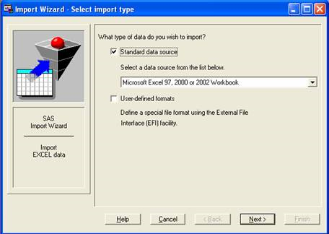
- Click Browse, then choose the Excel file (e.g. sales.xls) you want to import, and then click Ok.
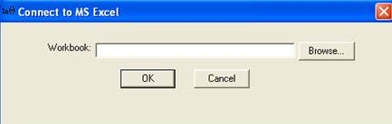
- Select the table you want to import, and then click Next.
Note: If your Excel file has multiple tables (or worksheets), click the pull-down menu to see the list of worksheets in that Excel file.
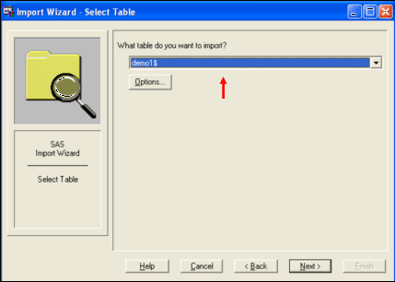
- Select Library and Member. Create a name (e.g. demo1) for your new file under Member, and then click Next.
Note: make sure to keep the same WORK folder unchanged.
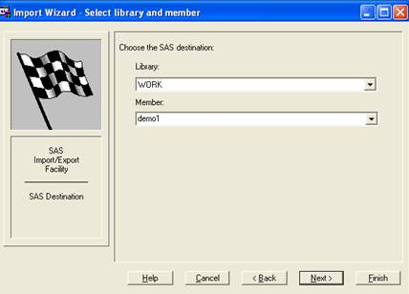
- Create SAS Statements. You may skip this step and click Finish.
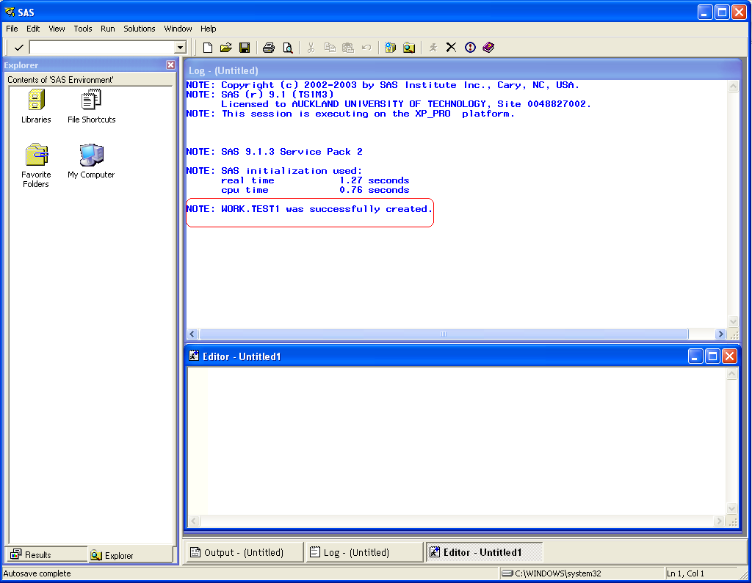

- Creating data using SAS
Note: the datalines statement is placed immediately after defining the variables names using input statement. For example:
DATA test;
INPUT id sex $ age inc r1 r2 r3;
DATALINES;
1 F 35 17 7 2 2
17 M 50 14 5 5 3
33 F 45 6 7 2 7
49 M 24 14 7 5 7
65 F 52 9 4 7 7
81 M 44 11 7 7 7
2 F 34 17 6 5 3
18 M 40 14 7 5 2
34 F 47 6 6 5 6
50 M 35 17 5 7 5
;
PROC PRINT; RUN;

The output from this run looks as follows:
OBS ID SEX AGE INC R1 R2 R3
1 1 F 35 17 7 2 2
2 17 M 50 14 5 5 3
3 33 F 45 6 7 2 7
4 49 M 24 14 7 5 7
5 65 F 52 9 4 7 7
6 81 M 44 11 7 7 7
7 2 F 34 17 6 5 3
8 18 M 40 14 7 5 2
9 34 F 47 6 6 5 6
10 50 M 35 17 5 7 5

The variable SEX in the INPUT statement is followed by a dollar sign ($) indicating that this is a character variable. Without using a dollar sign ($), SAS assumes that this variable is numeric. Thus, it will assign a missing value (.) to the variable for that observation. So, the result is as follows:
OBS ID SEX AGE INC R1 R2 R3
1 1 . 35 17 7 2 2
2 17 . 50 14 5 5 3
3 33 . 45 6 7 2 7
4 49 . 24 14 7 5 7
5 65 . 52 9 4 7 7
6 81 . 44 11 7 7 7
7 2 . 34 17 6 5 3
8 18 . 40 14 7 5 2
9 34 . 47 6 6 5 6
10 50 . 35 17 5 7 5

- Examining the data
Table 1 lists descriptive statistics options available in SAS.
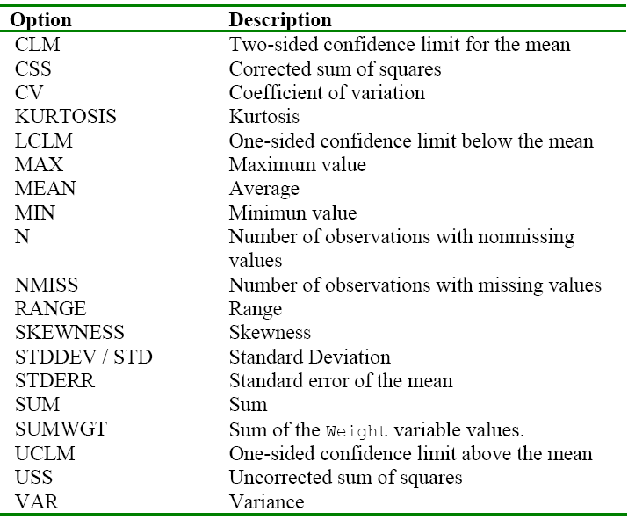

Table 2 lists the PROC statements available in SAS.
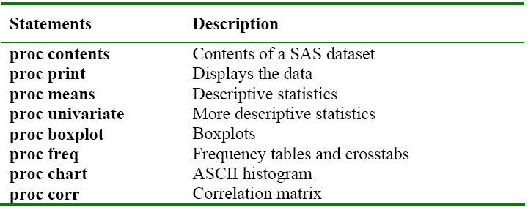

Examples for using some simple PROC statements to analyse the data:
- PROC PRINT – to print your data on the Output menu
data demo1; * indicates the data file to be used;
proc print; * prints data found in the “demo1”;
run; * runs and executes the program;
Hints: Always finish your command program with “run;”, and place the cursor after it before you execute the command. You also can comment the command lines by placing the text between star (*) and a semicolon (;), or using /*…*/.
Note: after you type these commands, click on the “running man” icon to execute your commands. Then you can view the results in the Output window.

- PROC MEANS – to view summary statistics (it will show the mean, standard deviation, min and max)
proc means data=demo1;
run;
Or you prefer to view the summary statistics of particular variable(s)
proc means data=demo1;
var x1 x2;
run;
Or you may customize data examination by using descriptive statistics options that are specified after the proc means statement. For example:
data demo1;
proc means min max; * generates min and max values of the dataset;
var x1 x2;
run;

- PROC SORT – the default sorts in ascending order. You may also customize such that it sorts in descending order. The command below will sort the data by the values of the variable y.
proc sort data=demo1;
by descending y; * specify the order & variable;
proc print; run;

Or if you want to get the summary statistics separately for Male and Female, you can first sort the data using PROC SORT and give additional command “by sex”. For example:
proc sort data=demo1;
by sex;
proc means data=demo1;
var x1 x2;
by sex;
proc print; run;

- PROC CHART – for Bar & Pie graph.
proc chart data=demo1;
vbar sex;
run;

proc chart data=demo1;
pie sex;
run;
- PROC PLOT – to create scatter plots on Y-X axis (vertical-horizontal).
proc plot data=demo1;
plot y*x1=’*’; * specify the Y and X;
run;

- PROC REG – Linear Regression
proc reg data=demo1;
model y=x1 x2 / cp; * specify the model and option to be estimated;
run;

Note: when specifying the model after the keyword MODEL, the dependent variable is specified, followed by an equal sign (=) and the regressor variables. Variables specified here must be only numeric. “cp” is the model selection criteria, but you may need to give some more options, such as:

Table 3 lists the OPTIONS available in SAS.
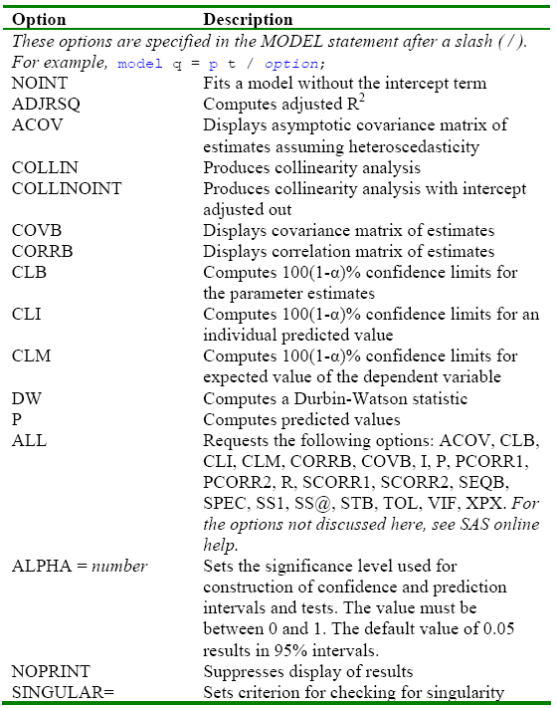

- Saving a SAS Program
Activate the Editor window by clicking in it, and then from the File pull-down menu select Save as. Then, enter a name for the SAS program and select the drive and directory where you wish to save the SAS program. Check the file type is *.sas, and then click OK.

